1️⃣ Data Source Layer
Purpose: Where your data originates.
In your case:
- Machine logs or IoT sensors (temperature, power, current, production time)
- Operator or shift log entries (Excel/manual input)
- ERP or production scheduling system (batch, grade, section)
Example Components:
- “EAF Sensor Data Logs”
- “Shift Operator Excel Files”
- “Production ERP System (Oracle/SQL)”

2️⃣ Data Ingestion Layer
Purpose: Bringing raw data into the system for analysis.
In your case:
- Excel uploads or database exports
- Scheduled data pulls (daily/hourly)
- CSV uploads from shop floor systems
Example Components:
- Power Query
- Python ETL Scripts
- SQL Import Jobs

3️⃣ Data Storage Layer
Purpose: Store raw and cleaned data.
In your case:
- Centralized SQL Database or shared drive (structured Excel files)
- Organized by date, heat number, or shift
Example Components:
- “Raw_Data” folder in Shared Drive
- SQL Database: Manufacturing_DB
- Data Warehouse (optional for scaling)

4️⃣ Data Processing & Transformation Layer
Purpose: Clean, filter, and transform raw data into analysis-ready format.
In your case:
- Remove missing or duplicate values
- Convert timestamps and calculate KPIs (e.g., Melt Time, Energy per Ton)
- Merge multiple data sources if required
Tools:
- Power Query (Power BI)
- Python (Pandas, NumPy)
- SQL Views or Stored Procedures

5️⃣ Data Visualization / Reporting Layer
Purpose: Create dashboards and reports for management and operations.
In your case:
- Power BI dashboards showing KPIs like:
  - Energy Efficiency per Heat
  - Production Trends
  - Shift-wise Productivity
  - Downtime Analysis
Example Outputs:
- Power BI Dashboard
- Excel Summary Reports
- Monthly Performance Report (PDF)

6️⃣ Insights & Decision Layer (Optional but Valuable)
Purpose: Turning analysis into business action.
In your case:
- Identify bottlenecks in production
- Track high energy-consuming heats
- Recommend shift-level optimizations
Used by:
- Production Heads
- Plant Supervisors
- Management

🔁 Data Flow (Simplified)
Data Sources (Machines, Operators, ERP)
↓
Data Ingestion (Excel Upload / API / ETL)
↓
Data Storage (SQL / Data Lake / Excel)
↓
Data Transformation (Python / Power Query)
↓
Data Visualization (Power BI Dashboards)
↓
Insights & Decision Making (Reports / Alerts)

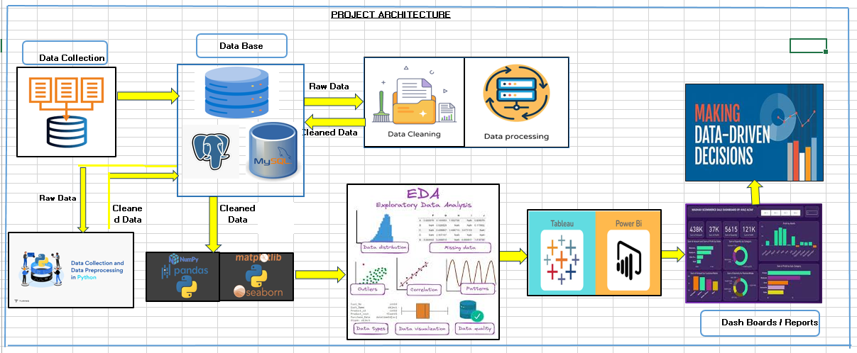

Architecture Diagram Documentation Template

1. Introduction and Purpose
This section provides high-level context for the entire architecture.
Element | Description Template
Title | [Project Name] Data Analysis Architecture Diagram Description
Document Version | v1.0 (Initial Draft/Final)
Date | [Current Date]
Purpose | This document describes the end-to-end flow of data for the [Project Goal, e.g., Customer Churn Analysis] project. It outlines the journey from raw data ingestion through cleaning and analysis to final insight delivery.

2. Data Flow Summary (The "High Road")
This is a concise, step-by-step narrative that matches the flow shown in the diagram.
Element | Description Template
Data Ingestion | The process begins with data sourced from the [Primary Source, e.g., CRM Database] and [Secondary Source, e.g., Web Logs/CSV Files].
Staging/Load | Raw data is initially loaded into the [Staging Area, e.g., AWS S3 Bucket or Staging Schema in SQL DB] to preserve the original format.
Transformation/Cleaning | Data is pulled from staging into a Python environment using the Pandas library, where data cleaning, preprocessing, and feature engineering are performed. This ensures data is valid, complete, and consistent.
Analysis Layer | The cleaned dataset is stored in the [Final Data Store, e.g., Cleaned Schema/Analytical Table] where it is used for Exploratory Data Analysis (EDA) and SQL-based metric calculation.
Output/Delivery | Final metrics and key performance indicators (KPIs) are extracted to power the Power BI Dashboard, providing interactive visualization for end-users.

3. Key Components and Technologies
This section calls out the specific tools used at each stage, as visualized in the diagram.
Component | Technology Used | Role in Project
Data Sources | [e.g., Salesforce CRM, Google Analytics, Excel Uploads] | Provides the raw, unstructured, or transactional data for analysis.
Processing Engine | Python (Pandas/NumPy) | Core engine for all ETL (Extract, Transform, Load) and statistical processing, ensuring data quality and readiness.
Data Storage | [e.g., PostgreSQL/Snowflake Data Warehouse] | Centralized, performant storage for the cleaned, final analytical dataset.
Query/Metrics | SQL (Structured Query Language) | Used for complex filtering, aggregation, and the definition of all final business metrics used in the dashboard.
Visualization | Power BI / Tableau | Used to create the final interactive reports and dashboards, making the insights accessible to business stakeholders.

